Recommended lunch restaurant : Casa da Vó
Address: R. Xavier da Silva, 485 - Centro, Ponta Grossa - PR, 84010-250
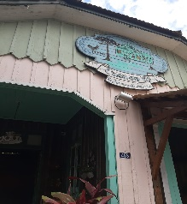
( close to University) lunch must be paid individually at the restaurant.
The transportation from University to restaurant will be free.
( Tueday )Conference Dinner at
Rua Antonio João, 282 - Jardim Carvalho | Ponta Grossa/PR- Dinner must be paid individually at the restaurant.
It’s is possible to have diner at Barbur Center Hotel (official hotel)
Schedule of Conference will be in (Brazilian time)
Google meeting link to every day
link:
meet.google.com/bai-qpwh-xvd
Registration Free
The Conference will be held in the Electrical Department of UTFPR: Federal University of Technology – Paraná, Ponta Grossa
J. M . Balthazar and A .M . Tusset(Chairs )-International DYCAELS 2023

